 Project Report



**MACHINE LEARNING WITH PYTHON**

**Project Title :** OPTIMIZING FLIGHT BOOKING DECISIONS THROUGH MACHINE LEARNING PRICE PREDICTIONS

**Team Leader :** GOKULRAJ K

**Team Member :** SINGADURAI K

**Team Member :** JAGADHESHWARAN P

**Team Member :** VIJAYKARTHICK V

* **INTRODUCTION**
* Overview

OPTIMIZING FLIGHT BOOKING DECISIONS THROUGH MACHINE LEARNING PRICE PREDICTIONS

* Purpose

Predict the price flight ticket.

**2 Problem Definition & Design Thinking**

2.1 Empathy Map

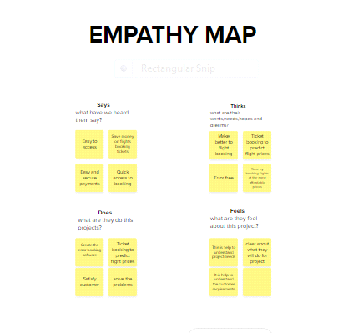

2.2 Ideation & Brainstorming Map

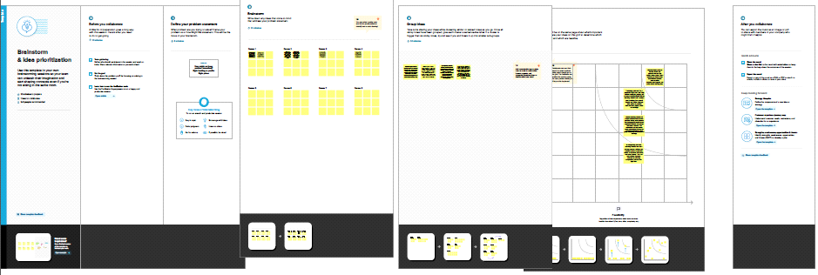

**RESULT:**

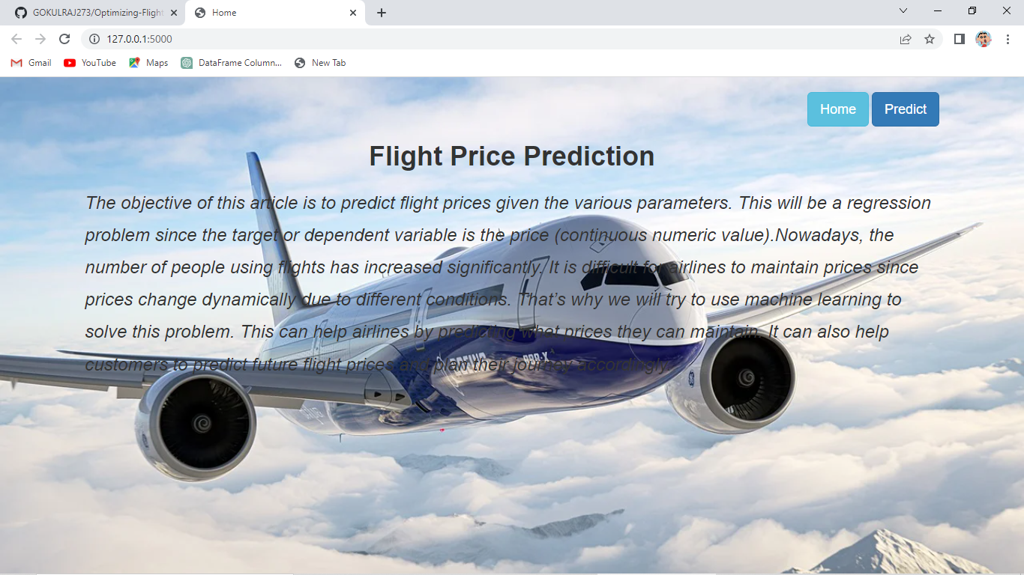





* Data Model:

|  |  |  |  |  |
| --- | --- | --- | --- | --- |
| **Object name** | **Fields in the Object** | | | |
| obj1 |  | | | |
|  | Field label | Data type |  |
| Airline | int |
| source | int |
| price | int |
| obj2 |  |  |  | |
| Field label | Data type |  |
| Destinesion | int |
| Dup_time | int |
| artime int | |

* **Activity & Screenshot**

Attach the screenshots of your project activity along with the description.

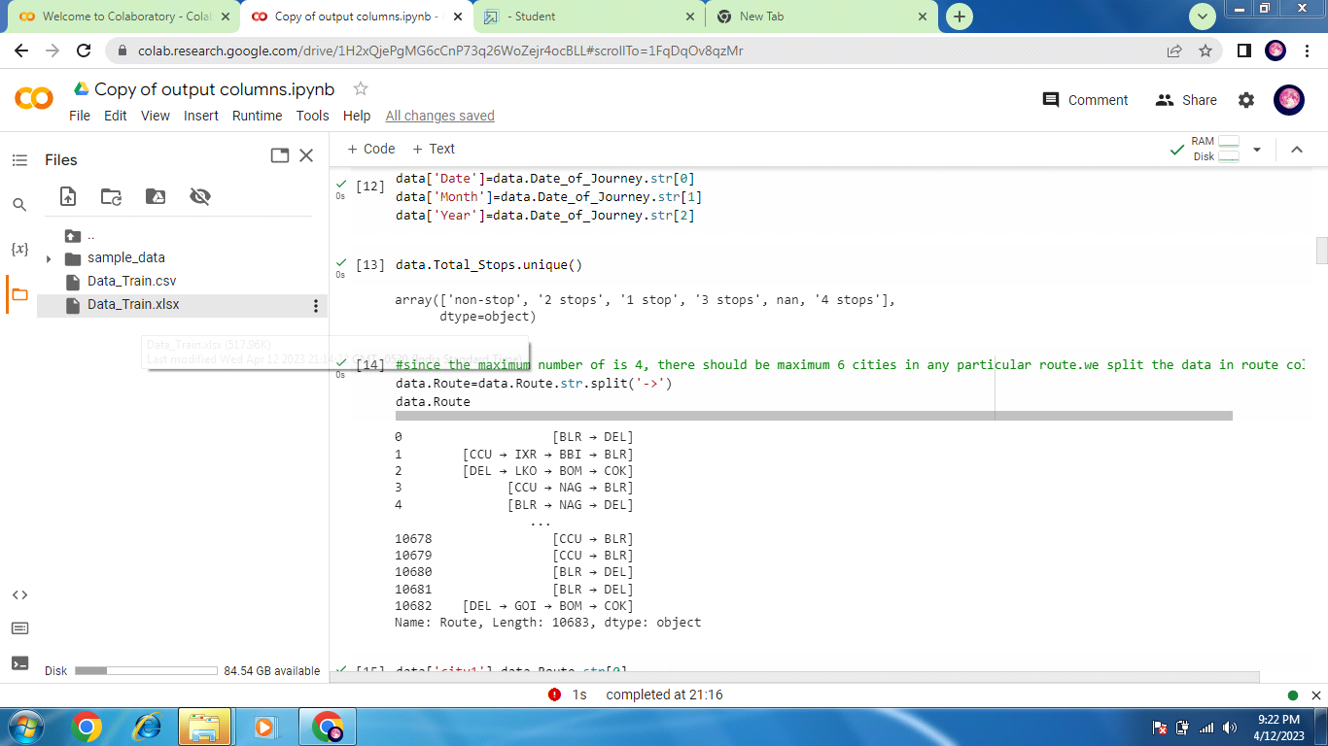

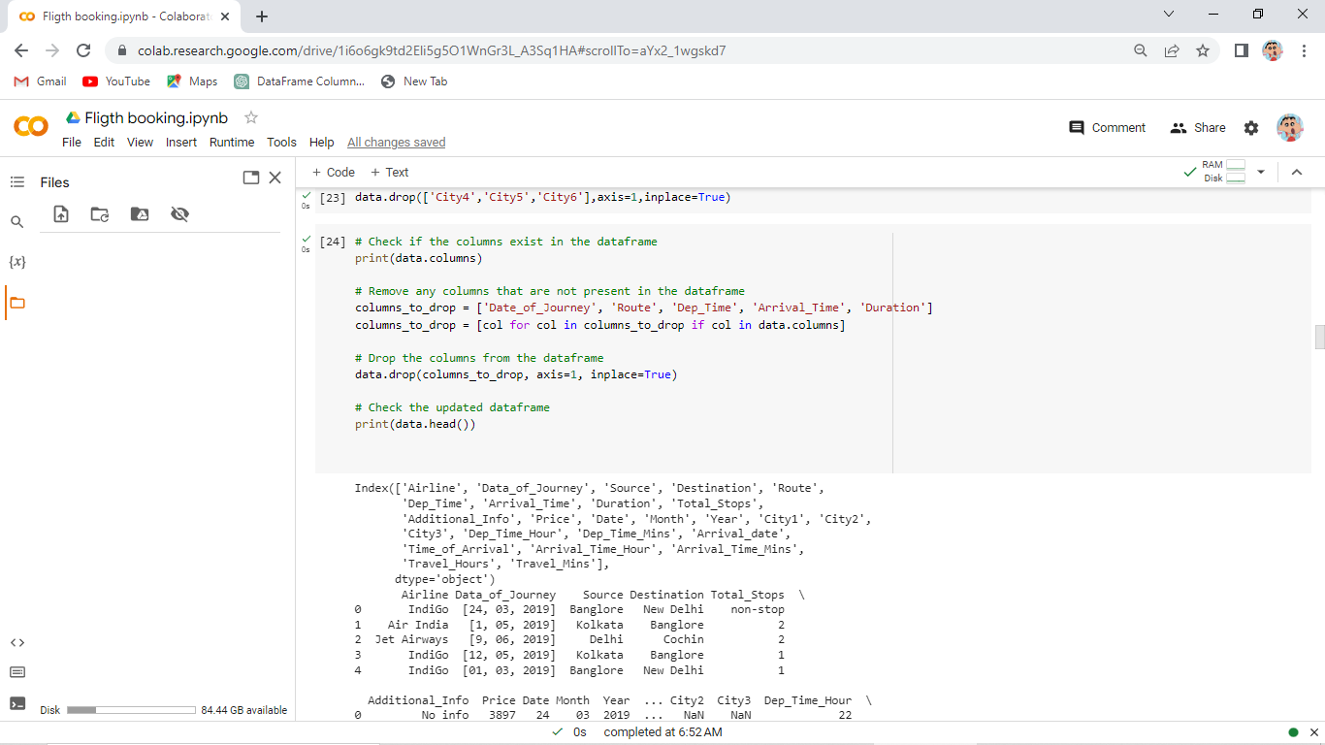

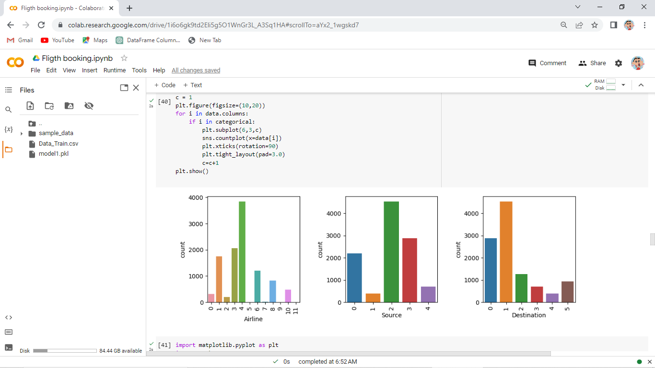

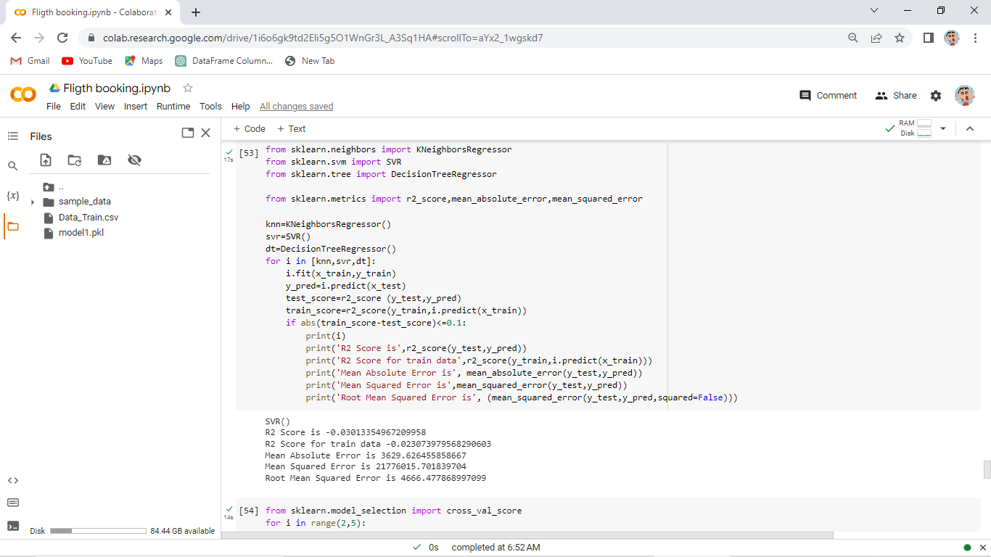

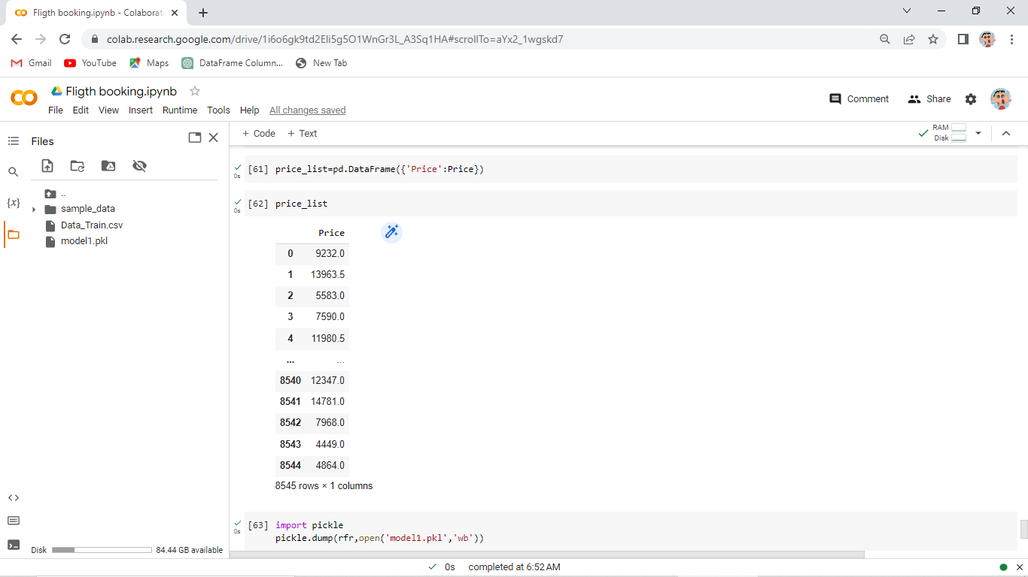

* **Trailhead Profile Public URL**

**Team Lead:** [**https://trailblazer.me/id/gokuk14**](https://trailblazer.me/id/gokuk14)

**Team Member 1 -** [**https://trailblazer.me/id/sdurai49**](https://trailblazer.me/id/sdurai49)

**Team Member 2 -**

**Team Member 3 –**

 Project Report Template

* **ADVANTAGES & DISADVANTAGE**

List of advantages and disadvantages of the proposed solution

Advantage:

* Learning video are helpful to understanding concept and help to create program.

* It is help to predict the correct for flight booking.

*Web design is well give attractive look to custumer.

Disadvantage:

*Nothing to say

* **APPLICATIONS**

Google colab ,Anoconda,Pycharm Community.

* **CONCLUSION**

We gave our best.We make good prediction for the flight booking.

* **FUTURE SCOPE**

It will use predict price for fligth booking

**Appendix**

A Source Code :-

#Import Lib

import numpy as np

import pandas as pd

import matplotlib.pyplot as plt

import seaborn as sns

from sklearn.model_selection import train_test_split

from sklearn.ensemble import RandomForestClassifier, GradientBoostingClassifier

from sklearn.tree import DecisionTreeClassifier

from sklearn.neighbors import KNeighborsClassifier

from sklearn.metrics import f1_score

from sklearn.metrics import classification_report, confusion_matrix

import warnings

import pickle

from scipy import stats

warnings.filterwarnings('ignore')

**#Read the Dataset**

data = pd.read_csv('/content/Data_Train.csv')

**#Data Preparation**

for i in data.select_dtypes(include='object'):

print(i, data[i].unique())

data = data.rename(columns={'Date_of_Journey': 'Data_of_Journey'})

data.Data_of_Journey = data.Data_of_Journey.str.split('/')

data['Date']=data['Data_of_Journey'].str[0]

data['Month']=data['Data_of_Journey'].str[1]

data['Year']=data['Data_of_Journey'].str[2]

data.Route=data.Route.str.split('->')

data['City1']=data.Route.str[0]

data['City2']=data.Route.str[1]

data['City3']=data.Route.str[2]

data['City4']=data.Route.str[3]

data['City5']=data.Route.str[4]

data['City6']=data.Route.str[5]

data.Dep_Time=data.Dep_Time.str.split(':')

data['Dep_Time_Hour']=data.Dep_Time.str[0]

data['Dep_Time_Mins']=data.Dep_Time.str[1]

data.Arrival_Time=data.Arrival_Time.str.split('')

data['Arrival_date']=data.Arrival_Time.str[1]

data['Time_of_Arrival']=data.Arrival_Time.str[0]

data['Time_of_Arrival']=data.Time_of_Arrival.str.split(':')

data['Arrival_Time_Hour']=data.Time_of_Arrival.str[0]

data['Arrival_Time_Mins']=data.Time_of_Arrival.str[1]

data.Duration=data.Duration.str.split(' ')

data['Travel_Hours']=data.Duration.str[0]

data['Travel_Hours']=data['Travel_Hours'].str.split('h')

data['Travel_Hours']=data['Travel_Hours'].str[0]

data.Travel_Hours=data.Travel_Hours

data["Travel_Mins"]=data.Duration.str[1]

data.Travel_Mins=data.Travel_Mins.str.split('a')

data.Travel_Mins=data.Travel_Mins.str[0]

**#Replacing Missing Values**

data.Total_Stops.replace('non_stop',0,inplace=True)

data.Total_Stops=data.Total_Stops.str.split(' ')

data.Total_Stops=data.Total_Stops.str[0]

data.Additional_Info.replace('No Info','No info',inplace=True)

data.drop(['City4','City5','City6'],axis=1,inplace=True)

# Check if the columns exist in the dataframe

print(data.columns)

# Remove any columns that are not present in the dataframe

columns_to_drop = ['Date_of_Journey', 'Route', 'Dep_Time', 'Arrival_Time', 'Duration']

columns_to_drop = [col for col in columns_to_drop if col in data.columns]

# Drop the columns from the dataframe

data.drop(columns_to_drop, axis=1, inplace=True)

data['City3'].fillna('None',inplace=True)

data['Arrival_date'].fillna('None',inplace=True)

data['Travel_Mins'].fillna('None',inplace=True)

data['Travel_Mins'] = data['Travel_Mins'].str.rstrip('m') # remove 'm' character from the end of each string

data['Travel_Mins'] = data['Travel_Mins'].replace('None', '-1') # replace 'None' values with -1

data['Travel_Mins'] = data['Travel_Mins'].astype('int64') # convert to int64 datatype

#data['Total_Stops'] = data['Total_Stops'].astype('int64')

data['Date'] = data['Date'].astype('int64')

data['Month'] = data['Month'].astype('int64')

data['Year'] = data['Year'].astype('int64')

data['Dep_Time_Hour'] = data['Dep_Time_Hour'].astype('int64')

data['Dep_Time_Mins'] = data['Dep_Time_Mins'].astype('int64')

data['Arrival_date'] = data['Arrival_date'].astype('int64')

data['Arrival_Time_Mins'] = data['Arrival_Time_Mins'].fillna(-1).astype('int64')

#data['Travel_Hours'] = data['Travel_Hours'].astype('int64')

data['Travel_Mins'] = data['Travel_Mins'].astype('int64')

data[data['Travel_Hours']=='5']

data.drop(index=6474,inplace=True,axis=0)

data.Travel_Hours=data.Travel_Hours.astype('int64')

**#Label Encoding**

**from sklearn.preprocessing import LabelEncoder**

**le=LabelEncoder()**

**data.Airline=le.fit_transform(data.Airline)**

**data.Source=le.fit_transform(data.Source)**

**data.Destination=le.fit_transform(data.Destination)**

**data.Total_Stops=le.fit_transform(data.Total_Stops)**

**data.Cityl=le.fit_transform(data.City1)**

**data.City2=le.fit_transform(data.City2)**

**data.City3=le.fit_transform(data.City3)**

**data.Additional_Info=le.fit_transform(data. Additional_Info)**

**#Output Columns**

**data = data[['Airline','Source','Destination','Date','Month','Year','Dep_Time_Hour','Dep_Time_Mins','Dep_Time_Mins','Arrival_date','Arrival_Time_Hour','Arrival_Time_Mins','Price']]**

**# Exploratory Data Analysis**

data.describe()

**#Visual Analysis**

import seaborn as sns

import matplotlib.pyplot as plt

# Define categorical variables

categorical = ['Airline', 'Source', 'Destination', 'Additional_Info', 'City1']

# Create a plot for each categorical variable

c = 1

plt.figure(figsize=(10,20))

for i in data.columns:

    if i in categorical:

        plt.subplot(6,3,c)

        sns.countplot(x=data[i])

        plt.xticks(rotation=90)

        plt.tight_layout(pad=3.0)

        c=c+1

plt.show()

import matplotlib.pyplot as plt

import seaborn as sns

plt.figure(figsize=(15,8))

sns.distplot(data['Price'])

**#Checking the Correlation Using HeatMap**

sns.heatmap(data.corr(),annot=True)

**#Outlier Detection for 'Price' Column**

import seaborn as sns

sns.boxplot(data['Price'])

y = data['Price']

x = data.drop(columns=['Price'],axis=1)

x_scaled = ss.fit_transform(x)

x_scaled = pd.DataFrame(x_scaled)

x_scaled.head()

from sklearn.model_selection import train_test_split

x_train,x_test,y_train,y_test=train_test_split(x,y,test_size=0.2, random_state=42)

**#Using Ensemble Techniques**

from sklearn.ensemble import RandomForestRegressor, GradientBoostingRegressor, AdaBoostRegressor

rfr=RandomForestRegressor()

gb=GradientBoostingRegressor()

ad=AdaBoostRegressor()

from sklearn.metrics import r2_score, mean_absolute_error, mean_squared_error

for i in [rfr, gb, ad]:

    i.fit(x_train, y_train)

    y_pred = i.predict(x_test)

    test_score = r2_score(y_test, y_pred)

    train_score = r2_score(y_train, i.predict(x_train))

    if abs(train_score - test_score) <= 0.2:

        print(i)

        print("R2 score is", test_score)

        print("R2 for train data", train_score)

        print("Mean Absolute Error is", mean_absolute_error(y_pred, y_test))

        print("Mean Squared Error is", mean_squared_error(y_pred, y_test))

        print("Root Mean Absolute Error is", mean_squared_error(y_pred, y_test, squared=False))

**#Regression Model**

from sklearn.neighbors import KNeighborsRegressor

from sklearn.svm import SVR

from sklearn.tree import DecisionTreeRegressor

from sklearn.metrics import r2_score,mean_absolute_error,mean_squared_error

knn=KNeighborsRegressor()

svr=SVR()

dt=DecisionTreeRegressor()

for i in [knn,svr,dt]:

    i.fit(x_train,y_train)

    y_pred=i.predict(x_test)

    test_score=r2_score (y_test,y_pred)

    train_score=r2_score(y_train,i.predict(x_train))

    if abs(train_score-test_score)<=0.1:

        print(i)

        print('R2 Score is',r2_score(y_test,y_pred))

        print('R2 Score for train data',r2_score(y_train,i.predict(x_train)))

        print('Mean Absolute Error is', mean_absolute_error(y_test,y_pred))

        print('Mean Squared Error is',mean_squared_error(y_test,y_pred))

        print('Root Mean Squared Error is', (mean_squared_error(y_test,y_pred,squared=False)))

**# Checking Cross Validation for RandomForestRegressor**

from sklearn.model_selection import cross_val_score

for i in range(2,5):

    cv=cross_val_score(rfr,x,y,cv=i)

    print(rfr,cv.mean())

**#Hypertuning the model**

from sklearn.model_selection import RandomizedSearchCV

param_grid={'n_estimators': [10,30,50,70,100],"max_depth": [None,1,2,3],

'max_features':['auto', 'sqrt']}

rfr=RandomForestRegressor()

rf_res=RandomizedSearchCV(estimator=rfr, param_distributions=param_grid,cv=3,verbose=2,n_jobs=-1)

rf_res.fit(x_train,y_train)

gb=GradientBoostingRegressor()

gb_res=RandomizedSearchCV(estimator=gb, param_distributions=param_grid, cv=3, verbose=2,n_jobs=-1)

gb_res.fit(x_train,y_train)

**#Accuracy**

rfr=RandomForestRegressor(n_estimators=10,max_features="sqrt",max_depth=None)

rfr.fit(x_train,y_train)

y_train_pred=rfr.predict(x_train)

y_test_pred=rfr.predict(x_test)

print("train accuracy",r2_score(y_train_pred,y_train))

print("test accuracy",r2_score(y_test_pred,y_test))

**# Evaluating performance of the model and saving the model**

knn=KNeighborsRegressor (n_neighbors=2, algorithm="auto", metric_params=None,n_jobs=-1)

knn.fit(x_train,y_train)

y_train_pred=knn.predict(x_train)

y_test_pred=knn.predict(x_test)

print("train accuracy", r2_score (y_train_pred,y_train))

print("test accuracy",r2_score(y_test_pred,y_test))

Price=y_train_pred

price_list=pd.DataFrame({'Price':Price})

price_list

**#Model Deployment**

import pickle

pickle.dump(rfr,open('model1.pkl','wb'))